12/31/2019
TABAN DENIS JOHNSON
AFRICA INSTITUTE FOR PROJECT MANAGEMENT STUDIES
PGD IN PROJECT PLANNING AND MANAGEMENT
ASSIGNMENT FIVE ADM NO AIPMS/288/2019

Question 1. Explain briefly the types of project organization
Types of Project Organizational Structures
Organization is the key in a business and a project’s organizational structure can make or break a company’s main initiatives. If there’s too much bureaucracy and red tape, it might suffocate innovation. If there’s too much freedom, employees might struggle in confusing roles. These four types of project organization structures have had demonstrated success across a number of major companies. The one you choose for your project depends on your goals.
Forms of Project Organization: Functional
There’s a good chance that you’re already deeply acquainted with functional organization, or as it’s commonly called, the bureaucratic organizational structure. This is one of the most popular forms of project organization and is used across Fortune 500 companies and small businesses alike. If you’re running a small business, you probably have already mulled over this dedicated project team structure if you’ve thought about expanding beyond just a handful of employees.
At its heart, a functional organizational structure divides a project or organization into smaller groups that have dedicated, specific tasks. For example: an independently owned string of successful car dealerships might split their workforce into departments like sales, marketing and administration. Each of these departments has a head who reports to the CEO.
Though this is one of the forms of project organization that allows talent to specialize in what they’re truly good at, it also lacks interdepartmental communication. In other words: two departments may have entirely different expectations of the job, which causes disagreements and unexpected slowdowns. It also encourages employees to look at their specific tasks rather than the overall company.
Forms of Project Organization: Divisional
This dedicated project team structure is often chosen by larger companies that have a lot of objectives. It allows a company to focus on different roles within their business and gives a lot more self-sufficiency to the different departments. They essentially function like their very own individual businesses.
For example, a construction business might want to split their company into a commercial division, a residential division and a government division. If they have to build a school, that project would be given to the government division. If they are building an apartment complex, it might go to residential. Companies can also opt to split into geographical divisions. For example, that same construction company might branch off into Northeast, Midwest and Southeast divisions. Each division has its own resources and there isn’t much inter-division face time.
Unlike a functional organizational structure, where a marketing team will rely on the sales team to know what to market, divisional structures allow each department to function alone. This is one of the types of project organizational structures where projects are completed with little bureaucracy among departments and objectives remain clear within each department. It is not a loss to have so-called “tunnel-vision” like it would be in a functional structure, but it does make taxes a little bit more complicated – especially if departments are split regionally.
Forms of Project Organization: Matrix
This is one of the types of project organizational structures that has the best of both worlds. It’s essentially a hybrid between two forms of project organization: functional and divisional. In this case, a company is split into specialized teams like marketing, sales and administration, but those teams are also split into divisions like – keeping with the construction company example – government, residential and commercial.
Basically, you’ll have workers who primarily focus on the marketing of government contracts and others that focus on the marketing of residential contracts rather than a dedicated, overall marketing team (though members of the marketing team may be on both the government and residential team).
In this structure, employees don’t just have one boss. They have two or more bosses that focus on different objectives. This can make it confusing and hard for employees to define their role, but it can also help peel down the responsibilities of departments. It really just depends on how communicative upper management actually is.
Forms of Project Organization: Autarchy
Though tall types of project organization structures are most popular among larger companies, startups and small businesses may opt for a flat structure. This means there is no one way of communication. An employee does not report to the project manager, who reports to the department head, who reports to the CEO. The project manager can take decision-making all the way up to the CEO and the CEO can request things from the project manager if needed.

This structure opens up a lot of communication and dismisses unnecessary levels of bureaucracy that slow projects down, but it can also be kind of confusing if everyone involved doesn’t agree on the structure. In other words: an employee can easily run with an idea and become the project manager of a team that never previously existed, but that doesn’t mean the employees around her will want to take orders. Goodbye red-tape, and hello innovation. Just make sure to always keep the lines of communication open so the dedicated project team structures don’t get complicated when new teams arise. Loveland M., (2019 June 07), Types-project-organizational-structures. Types of Project Organizational Structures

Organization is the key in a business and a project’s organizational structure can make or break a company’s main initiatives. If there’s too much bureaucracy and red tape, it might suffocate innovation. If there’s too much freedom, employees might struggle in confusing roles. These four types of project organization structures have had demonstrated success across a number of major companies. The one you choose for your project depends on your goals.

Forms of Project Organization: Functional
There’s a good chance that you’re already deeply acquainted with functional organization, or as it’s commonly called, the bureaucratic organizational structure. This is one of the most popular forms of project organization and is used across Fortune 500 companies and small businesses alike. If you’re running a small business, you probably have already mulled over this dedicated project team structure if you’ve thought about expanding beyond just a handful of employees.
At its heart, a functional organizational structure divides a project or organization into smaller groups that have dedicated, specific tasks. For example: an independently owned string of successful car dealerships might split their workforce into departments like sales, marketing and administration. Each of these departments has a head who reports to the CEO.

Though this is one of the forms of project organization that allows talent to specialize in what they’re truly good at, it also lacks interdepartmental communication. In other words: two departments may have entirely different expectations of the job, which causes disagreements and unexpected slowdowns. It also encourages employees to look at their specific tasks rather than the overall company.

Forms of Project Organization: Divisional
This dedicated project team structure is often chosen by larger companies that have a lot of objectives. It allows a company to focus on different roles within their business and gives a lot more self-sufficiency to the different departments. They essentially function like their very own individual businesses.
For example, a construction business might want to split their company into a commercial division, a residential division and a government division. If they have to build a school, that project would be given to the government division. If they are building an apartment complex, it might go to residential. Companies can also opt to split into geographical divisions. For example, that same construction company might branch off into Northeast, Midwest and Southeast divisions. Each division has its own resources and there isn’t much inter-division face time.
Unlike a functional organizational structure, where a marketing team will rely on the sales team to know what to market, divisional structures allow each department to function alone. This is one of the types of project organizational structures where projects are completed with little bureaucracy among departments and objectives remain clear within each department. It is not a loss to have so-called “tunnel-vision” like it would be in a functional structure, but it does make taxes a little bit more complicated – especially if departments are split regionally.

Forms of Project Organization: Matrix
This is one of the types of project organizational structures that has the best of both worlds. It’s essentially a hybrid between two forms of project organization: functional and divisional. In this case, a company is split into specialized teams like marketing, sales and administration, but those teams are also split into divisions like – keeping with the construction company example – government, residential and commercial.
Basically, you’ll have workers who primarily focus on the marketing of government contracts and others that focus on the marketing of residential contracts rather than a dedicated, overall marketing team (though members of the marketing team may be on both the government and residential team).
In this structure, employees don’t just have one boss. They have two or more bosses that focus on different objectives. This can make it confusing and hard for employees to define their role, but it can also help peel down the responsibilities of departments. It really just depends on how communicative upper management actually is.

Forms of Project Organization: Autarchy
Though tall types of project organization structures are most popular among larger companies, startups and small businesses may opt for a flat structure. This means there is no one way of communication. An employee does not report to the project manager, who reports to the department head, who reports to the CEO. The project manager can take decision-making all the way up to the CEO and the CEO can request things from the project manager if needed.
This structure opens up a lot of communication and dismisses unnecessary levels of bureaucracy that slow projects down, but it can also be kind of confusing if everyone involved doesn’t agree on the structure. In other words: an employee can easily run with an idea and become the project manager of a team that never previously existed, but that doesn’t mean the employees around her will want to take orders. Goodbye red-tape, and hello innovation. Just make sure to always keep the lines of communication open so the dedicated project team structures don’t get complicated when new teams arise. Loveland, M. (2019 June 07).Types-project-organizational-structures.
Question 2. What are the phases available in project portfolio process?
Portfolio is as collection of projects, programs, subsidiary portfolios, and operations managed as a group to achieve strategic objectives. Program and project management focus on doing programs and projects the “right” way; and Portfolio management focuses on doing the “right” programs and projects.
PORTFOLIO MANAGEMENT
Defined as the centralized management of one or more portfolios to achieve strategic objectives. The programs or projects of the portfolio may not necessarily be interdependent or directly related. Aligns portfolios with organizational strategies by selecting the right programs or projects, prioritizing the work, and providing the needed resources.
The aim of portfolio management is to:
- Guide organizational investment decisions.
- Select the optimal mix of programs and projects to meet strategic objectives.
- Provide decision-making transparency.
- Prioritize team and physical resource allocation.
- Increase the likelihood of realizing the desired return on investment.
- Centralize the management of the aggregate risk profile of all components.
Portfolio management also conﬁrms that the portfolio is consistent with and aligned with organizational strategies.
Maximizing the value of the portfolio requires careful examination of the components that comprise the portfolio. Components are prioritized so that those contributing the most to the organization’s strategic objectives have the required ﬁnancial, team, and physical resources.
For example, an infrastructure organization that has the strategic objective of maximizing the return on its investments may put together a portfolio that includes a mix of projects in oil and gas, power, water, roads, rail, and airports. From this mix, the organization may choose to manage related projects as one portfolio. All of the power projects may be grouped together as a power portfolio. Similarly, all of the water projects may be grouped together as a water portfolio. However, when the organization has projects in designing and constructing a power plant and then operates the power plant to generate energy, those related projects can be grouped in one program. Thus, the power program and similar water program become integral components of the portfolio of the infrastructure organization.
- PROJECT PHASE: Collection of logically related project activities that culminates in the completion of one or more deliverables. Using multiple phases may provide better insight to managing the project. It also provides an opportunity to assess the project performance and take necessary corrective or preventive actions in subsequent phases
- PHASE GATE: A review at the end of a phase in which a decision is made to continue to the next phase, to continue with modification, or to end a program or project. (Phase review, stage gate, kill point, and phase entrance or phase exit) Eng. Abouzied M. E., (2019), PMBOK SUMMARY SIX EDITION.

Question 3. Explain the term risk management
Risk management is the act or practice of dealing with risk. It includes planning for risk, identifying risks, analyzing risks, developing risk response strategies, and monitoring and controlling risks to determine how they have changed. Risk management is not a separate project office activity assigned to a risk management department, but rather is one aspect of sound project management. Risk management should be closely coupled with key project processes, including but not limited to overall project management, systems engineering, configuration management, cost, design/engineering, earned value, manufacturing, quality, schedule, scope, and test. (Project management and systems engineering are typically the two top-level project processes. While risk management can be linked to either of these processes, it is typically associated with project management.) Proper risk management is proactive rather than reactive and positive rather than negative and seeks to increase the probability of project success. As an example, an item in a network (e.g., router) requires that a new technology be developed. The schedule indicates six months for this development, but project engineers think that nine months is much more likely. If the project manager is proactive, he or she might develop a risk response plan to address potential risks right now. If the project manager is reactive (e.g., a “problem solver”), then he or she may do nothing until the problem actually occurs. At that time the project manager must react rapidly to the crisis and may have lost valuable time during which contingencies could have been developed and at least some possible solutions may have been foreclosed. (The resulting cost, technical performance, schedule, and risk design solution space will also have likely contracted considerably versus when the project was initiated.) Hence, proper risk management will attempt to reduce the probability of an event occurring and/or the magnitude of its impact as well as increase the probability of project success. Kerzner H., (2017), Project management, twelfth edition.
Question 4. How are projects cushioned from risk?
A risk is anything that could potentially impact your project’s timeline, performance or budget. Risks are potentialities, and in a project management context, if they become realities, they then become classified as “issues” that must be addressed. So risk management, then, is the process of identifying, categorizing, prioritizing and planning for risks before they become issues. Below is an illustration of risk management process

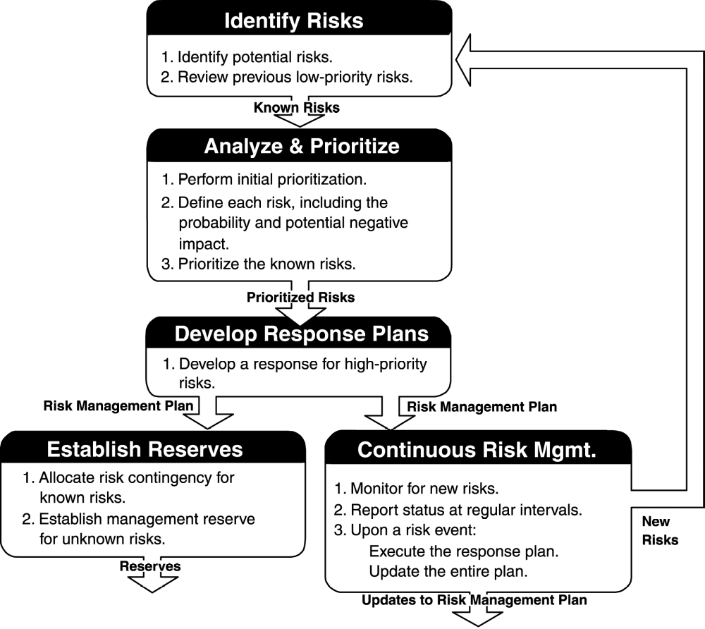
Identify risks. Systematically find all the factors that threaten project objectives. Identifying risk involves skill, experience, and a thorough knowledge of project management techniques—both the art and science of project management. There are four techniques for identifying risk: asking the stakeholders; making a list of possible risks (a risk profile); learning from past, similar projects; and focusing on the risks in the schedule and budget.
Analyze and prioritize. Assess each risk in terms of its possible damage and likelihood of occurrence. Most projects have an enormous number of potential risks. Quantifying the potential damage and the probability that a risk will occur enables the team to prioritize the risks, focusing their attention where it does the most good.
Develop a response. Create strategies for reducing the possible damage and/or probability the risk will occur. There are basically five categories of classic risk response strategies: accepting the risk, avoiding the risk, contingency plans, transferring the risk, and mitigating the risk.
Establish contingency and reserves. Set aside additional funding for the project that will be used in case specific risks occur—the known risks—as well as funding for the unknown risks.
Continuous risk management. Implement the strategies and monitor the effects of these changes on the project. Risk strategies may require fine-tuning as they are put into effect. Communicate with the stakeholders as new risks are found, known risks are avoided, and risk reserves are spent. Verzuh, E. (2016).The fast forward MBA in project management (5th Edition)
Question 5. Why is it important to plan for risk in execution of any project?
- It helps you to achieve the project’s objectives, thus ensuring the successful completion of the project
- The cost of addressing risks early far exceeds the negative impact if the risk event occurs.
- It allows you to decrease the possibility and impact of negative risks and increase the possibility and impact of positive risks.
- It helps you to explore new opportunities early and hence plan for them. A positive risk is an opportunity. When doing a construction project a reduction of the cost of galvanize is one such opportunity which can be exploited, if planned for.
- Enhances your ability to control your project’s implementation, as you are now aware and have planned for things that can go wrong in your project and have assigned responsibility for the identified risk and the risk response to a person on your team.
- It allows managers to make better strategic decisions.
- It help organizations avoid the negative impacts of litigation, etc. as a result of failed projects.
- The ultimate goal of good risk management practices for the organization is the protection and enhancement of shareholder value. Frederick, T. (2016). The Importance of Risk Management on Projects

Question 6. What can be a source of conflicts in a team and how can the same be solved
Below are the sources of conflicts at work places with ways of mitigating them.
Size Up Goals and Perceptions
Conflicting goals
Can create problems when an employee is asked by two different managers to achieve goals that contradict one another. Similarly, employees can be confused by business goals that don't always apply equally to all clients. Unbeknownst to employees, some clients may be entitled to extra special treatment.
Solution: Clear communication.

Conflicting perceptions
Spring from myriad causes, including customer complaints, office politics and the office grapevine. And the perception isn't the bad part; how employees process it is. You can't stop people from talking any more than you can read people's minds. But you can stay alert to changes in your office climate and tapping your most trusted sources for insights.
Solution: Proactive behavior.
Size Up Policies and Pressures
Conflicting policies
Can create unrest in the workplace when employees are unaware that they've been enacted, or – sometimes worse – don't have a clue as to why policies have been adopted. Even “peaceful protests” of company policies can have reverberating or echoing effects.
Solution: Swift communication and ongoing review of policies and procedures.
Conflicting pressures,
Like conflicting goals, can send mixed signals. The level of urgency usually rises with conflicting pressures, which often involve tasks of a more time-sensitive nature.
Solution: Better communication and, perhaps, new deadlines.

Size Up Resources and Roles
Conflict over resources
Is bound to happen in a small business, where things like equipment, supplies and especially money may be stretched to the limit. Employees should not see favoritism in these conflicts, but they must see a company's priorities.
Solution: Proper planning and communication.
Conflicting roles,
like conflicting perceptions, can trigger hurt feelings, power struggles and retaliatory moves when employees take ownership of a new role on their own or are asked to by a manager. For example, if you regularly ask one employee in particular to fill in for you in your absence, he may be confused by which role – boss, subordinate or both – you want him to assume first.
Solution: Clear communication, maybe followed by a clear office memorandum.
Size Up Styles and Values
Conflicting styles
Can be one of the more annoying in workplace conflicts to resolve, unless people ultimately – and peacefully – “agree to disagree.” You can no more expect a feisty, high-charging marketing manager to change his style than your reserved and soft-spoken accountant to alter his.
Solution: Tolerance, patience and the realization that everyone brings different skills and talents to your small business.

Conflicting values
Brew workplace trouble particularly when business values conflict with personal values. You're not always going to be on the same page with your employees personally, but it's imperative that there is no question about your “higher” business values, such as honesty, ethical behavior and professional conduct.
Solution: Communication and consistency.
Communication Matters
It's probably no surprise that poor communication lies at the root of most workplace conflict. This realization doesn't always make conflict easier to resolve, but opening a dialogue by establishing some common ground ought to get you started. So should staying committed to finding a solution, especially when a fast or easy answer seems intangible.
As you may know from your personal life, a “funny” thing can happen when you successfully resolve a conflict: You tend to anxiety the prospect a lot less, knowing from experience that you've conquered a problem before and you can do it again. This can be an empowering concept – and one that your business will benefit from. Wroblewski, M.T. (2019, March 16). Eight Sources of Conflict. Small Business.

Question 7. Give some ideas citing relevant examples for successful and better project teams.
Strong team leadership. Teams need a strong leader. This doesn’t mean someone who will take charge and make all the decisions. On the contrary, a good team leader will bring out the best in the team members. They will know the individual strengths and weaknesses of the team and utilize that information to ensure the team composition has the right combination of skills to be successful. In fact, a good team leader will find a way to ensure that team members have opportunities for development so those weaknesses can eventually become strengths. A strong leader empowers the team members to work through issues and make decisions, but knows when to step in to keep the team moving forward.
Common goals and objectives. It is common that when individuals first come together to form a team, each individual members has his/her own goals and objectives. The role of the team leader is to ensure that the team focuses around common goals and objectives. He/she does this by getting the team to agree on the goals for the project and develop a strategy for reaching those goals. Agreeing on a common goal does not mean individual goals need to be pushed aside. A strong leader can help marry individual goals to the common goal to benefit the individual team members and the team as a whole. Following a common goal helps provide direction to the team and sets the stage for moving forward.
Processes for getting things done. A team must have a way of working together. There must be processes that the team members follow to make decisions, assign tasks, manage conflicts that arise, and achieve their goals.
Diversity among members. Diversity includes not just race, gender or cultural differences; but also diversity in experiences and skills. Diversity among team members is essential to ensure that members have the skills and experience necessary to manage the tasks they are assigned and meet their goals. A diverse team in the sense of race, gender and cultural differences, especially for global projects, enables a broader perspective on the project.
Time to learn about each other. Take the time, before the project kicks into gear, to enable the project team members to spend some time together and get to know each other. This helps to build trust which is needed if a team is going to be effective. The more the team members know about each other, the more comfortable they become working together, challenging ideas, offering suggestions and in helping each other out to ensure goals are accomplished. Abudi, G. (2011).5 Elements of Successful Project Teams

References
- Loveland, M. (2019 June 07).Types-project-organizational-structures.
- Kerzner H., (2017), Project management, twelfth edition.
- Verzuh, E. (2016).The fast forward MBA in project management (5th Edition)
- Frederick, T. (2016). The Importance of Risk Management on Projects
- Abudi, G. (2011).5 Elements of Successful Project Teams

